Note: 390374.1 in my oracle support

Note: 390374.1 Oracle Performance Diagnostic Guideto assist customers with classification and tuning of various performanceDiagnosticGuidetoassistcustomerswithclassificationandtuningofvariousperformanceissues.

,Note:210014.1HowtoLogaGoodPerformance Service Request,” to guide you in logging a performance service request (SR

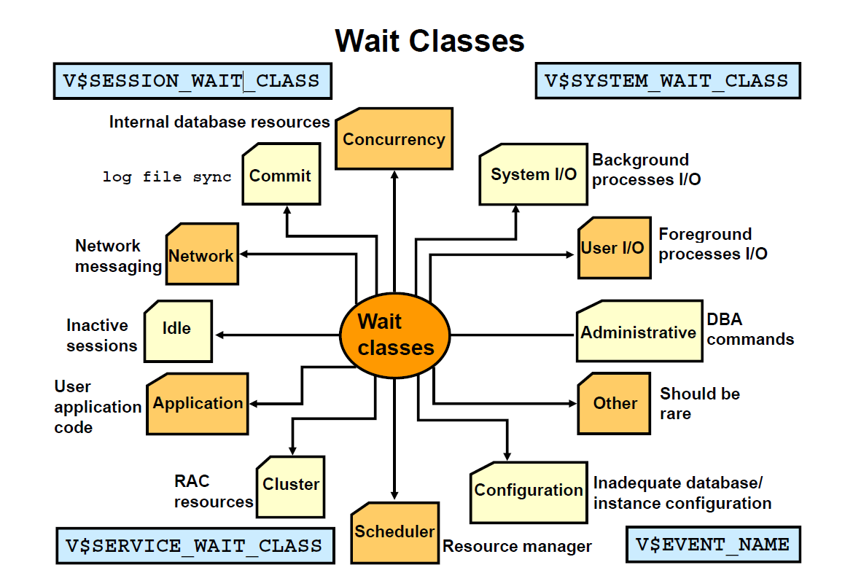

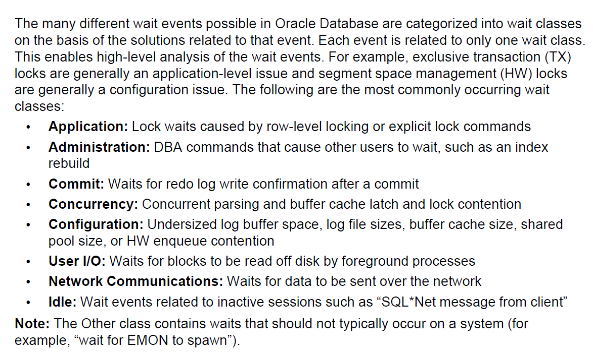

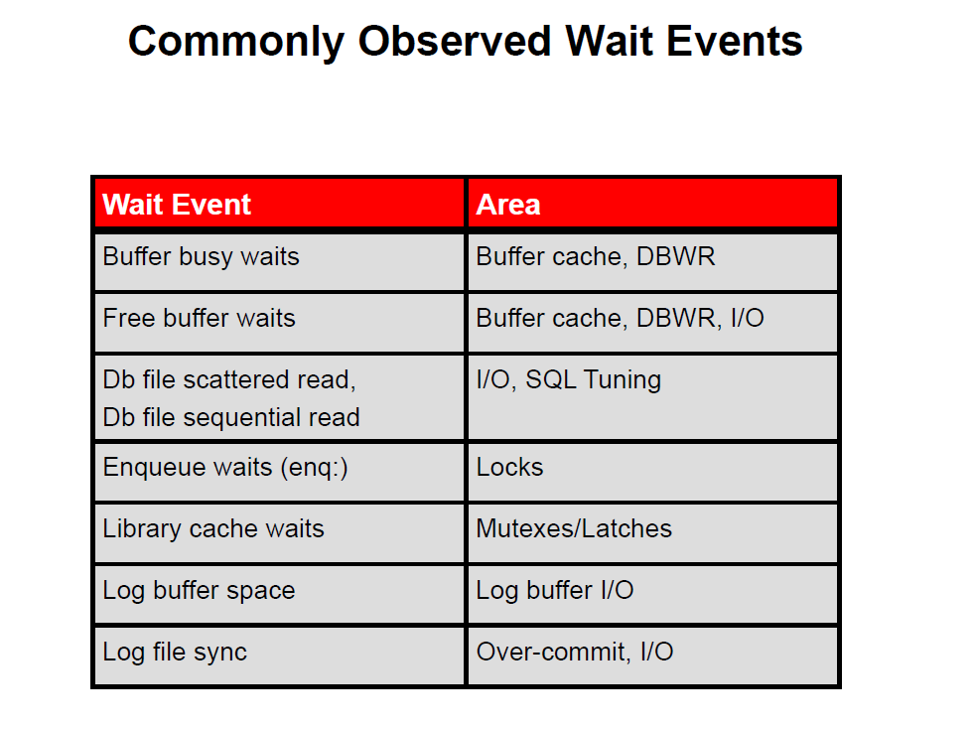

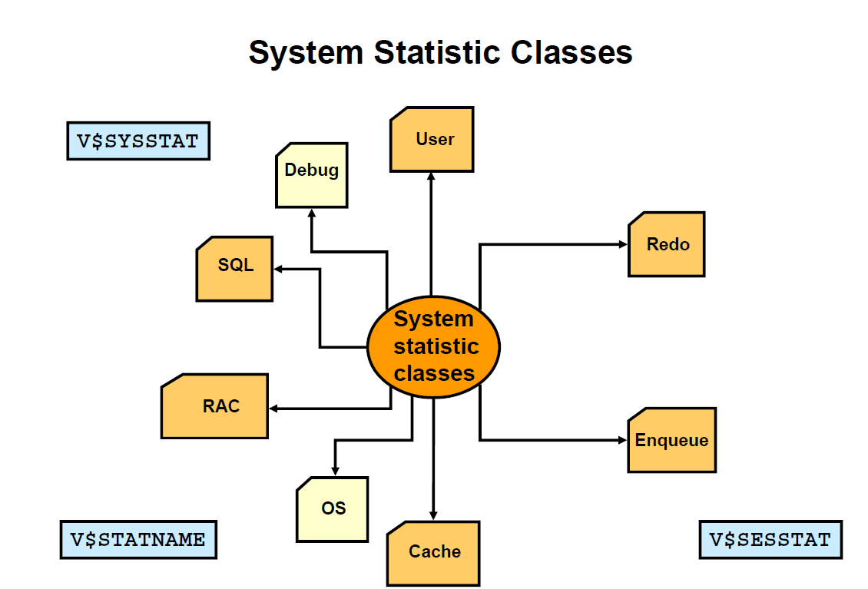

Determine the sessions that consume more than 30,000 bytes of PGA memory.

SELECT username, name, value FROM v$statname n, v$session s, v$sesstat t WHERE s.sid=t.sid AND n.statistic#=t.statistic# AND s.type='USER' AND s.username is not null AND n.name='session pga memory' AND t.value > 30000;

SELECT * FROM v$sgainfo;

Views that include microsecond timings:

–V$SESSION_WAIT, V$SYSTEM_EVENT, V$SERVICE_EVENT, V$SESSION_EVENT (TIME_WAITED_MICROcolumn)

–V$SQL, V$SQLAREA (CPU_TIME, ELAPSED_TIMEcolumns)

–V$LATCH, V$LATCH_PARENT, V$LATCH_CHILDREN (WAIT_TIMEcolumn)

–V$SQL_WORKAREA, V$SQL_WORKAREA_ACTIVE (ACTIVE TIMEl)(ACTIVE_TIMEcolumn)

•Views that include millisecond timings:

–V$ENQUEUE_STAT (CUM_WAIT_TIMEcolumn)

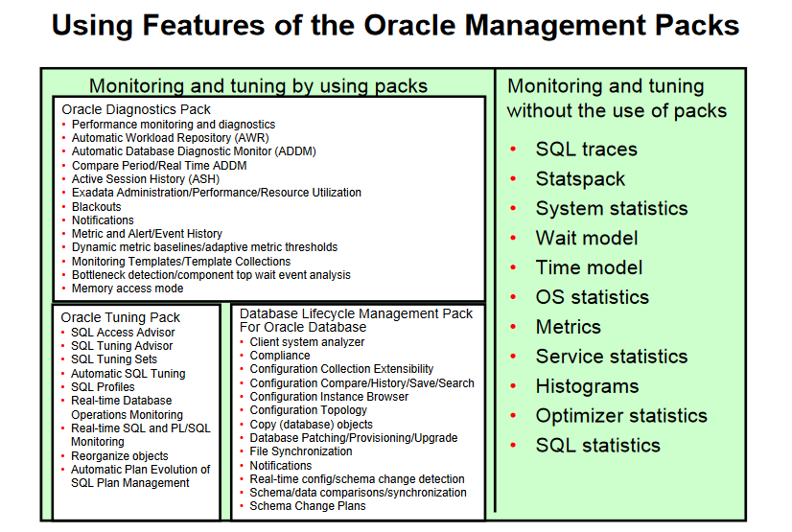

Oracle Diagnostic Pack provides automatic performance diagnostic and advanced system-monitoring functionality. Features can also be accessed through APIs and commands:

•The DBMS_WORKLOAD_REPOSITORYpackage

•TheDBMS ADDMpackageTheDBMS_ADDMpackage

•The DBMS_ADVISORpackage, if you specify ADDMas the value for the ADVISOR_NAMEparameter, or if you specify any value starting with the ADDMprefix for the value of the TASK_NAMEparameter

•The DBMS_WORKLOAD_REPOSITORYpackage

•The V$ACTIVE_SESSION_HISTORYdynamic performance view

•All data dictionary views beginning with theDBA HISTprefix along with theirAlldatadictionaryviewsbeginningwiththeDBA_HIST_prefix, alongwiththeirunderlying tables

•All data dictionary views with the DBA_ADVISOR_prefix if queries to these views return rows with the value ADDMin the ADVISOR_NAMEcolumn or a value of ADDM*in the TASK_NAMEcolumn or the corresponding TASK_ID

•The DBA_STREAMS_TP_PATH_BOTTLENECKview

•All views beginning with DBA ADDMgg__

•The following reports found in the /rdbms/admin/directory of the ORACLE_HOMEdirectory are part of this pack: awrrpt.sql, awrrpti.sql, addmrtp.sql, addmrpti.sql, ashrpt.sql, ashrpti.sql, awrddrpt.sql, awrddrpi.sql, awrsqrpi.sql, awrsqrpt.sql, awrextr.sql, andawrload.sql, awrextr.sql, awrload.sql,awrinfo.sql, spawrrac.sql.Oracle Tuning Pack provides expert performance management for the Oracle Database it i l diSQL tid tti i tiTh Ol Diti P k ienvironment, including SQLtuning and storage optimizations. The Oracle Diagnostic Packis a prerequisite product to the Oracle Tuning Pack. Features of the pack can also be accessed through APIs and commands:

•The DBMS_SQLTUNEpackage

•The DBMS_ADVISORpackage, when the value of the ADVISOR_NAMEparameter is either SQL Tuning Advisoror SQL Access Advisor

•V$SQL MONITOR

•V$SQL_MONITOR

•V$SQL_PLAN_MONITOR

•The sqltrpt.sqlreport found in the /rdbms/admin/directory of the ORACLE_HOMEdirectory

To view the alert log with ADRCI:

•Start ADRCI in interactive mode.$ adrciadrci> show alertad cso aetChoose the home from which to view the alert log:1: diag/rdbms/emrep/emrep2: diag/rdbms/orcl/orcl3: diag/tnslsnr/EDRSR7P1/listenerQt itQ: to quitPlease select option: 2

•If more than one ADR home is current, you are prompted to select a single ADR home from a list. The alert log is displayed, with XML tags omitted, in your default editor.

•Exit the editor to return to the ADRCI command prompt.

•ADRCI has the command option to search the alert log by a key value, and send output to terminal or file. To see the SHOW ALERToptions, use the helpcommand.

adrci> HELP SHOW ALERT

Session-Level Tracing

EXECUTE DBMS_MONITOR.SESSION_TRACE_ENABLE (8,12, waits=>TRUE, binds=>TRUE);;

The DBMS_MONITORpackage is created when the catproc.sqlscript is run. This script is located in the following directory:

•On UNIX:$ORACLE_HOME/rdbms/admin

•On Windows:%ORACLE HOME%\rdbms\adminOnWindows:%ORACLE_HOME%\rdbms\adminTo enable the writing of a trace file for your current session, execute the following command:EXECUTE DBMS_SESSION.SET_SQL_TRACE(TRUE)

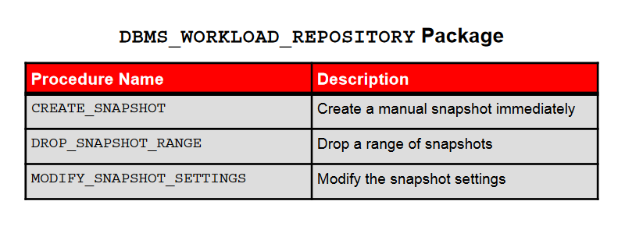

DBMS_WORKLOAD_REPOSITORY.MODIFY_SNAPSHOT_SETTINGS(retentionIN NUMBER DEFAULT NULLretentionINNUMBERDEFAULTNULL,intervalIN NUMBER DEFAULT NULL,topnsql IN NUMBER DEFAULT NULL);

DBMS_WORKLOAD_REPOSITORY.CREATE_SNAPSHOT(};

DBMS_WORKLOAD_REPOSITORY.DROP_SNAPSHOT_RANGE(LOW SNAP ID => 102,Drop one or more snapshots:__HIGH_SNAP_ID => 105);

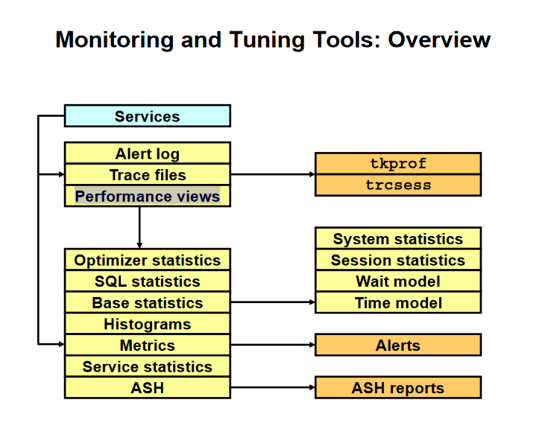

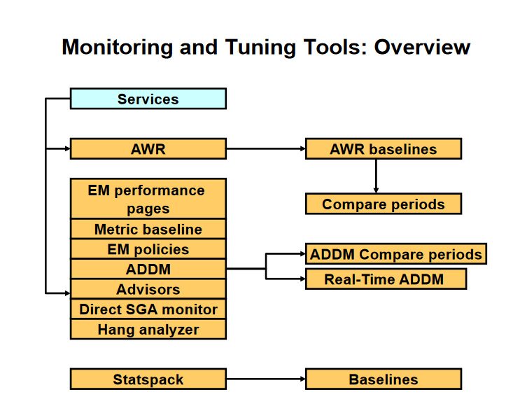

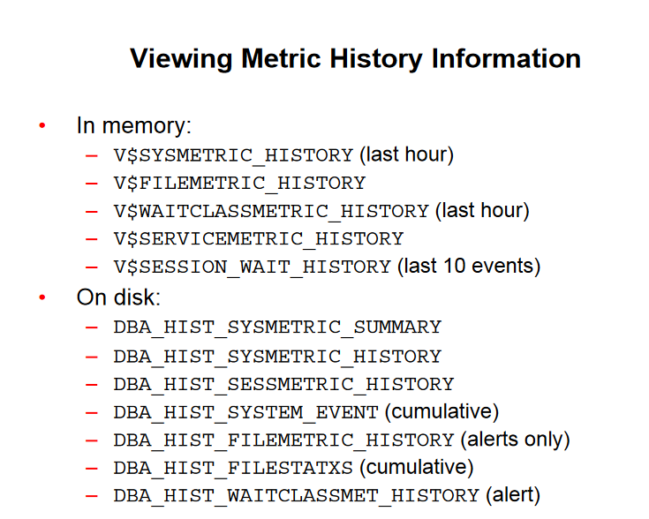

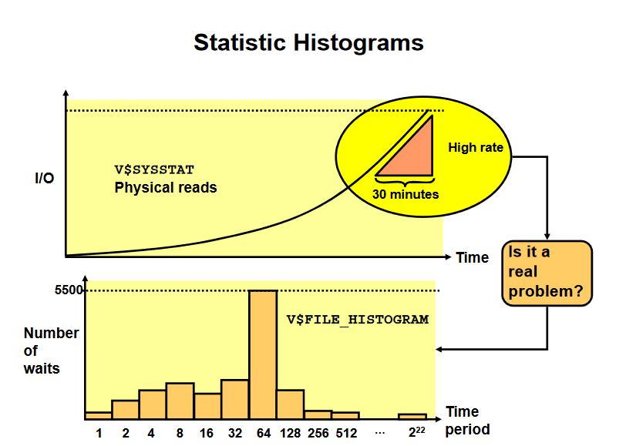

V$EVENT_HISTOGRAM: For each event such as “db file sequential read”

•V$FILE_HISTOGRAM: For single block reads on a per data file basis

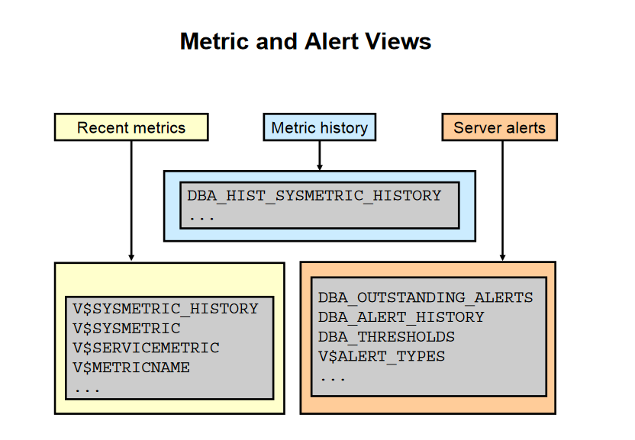

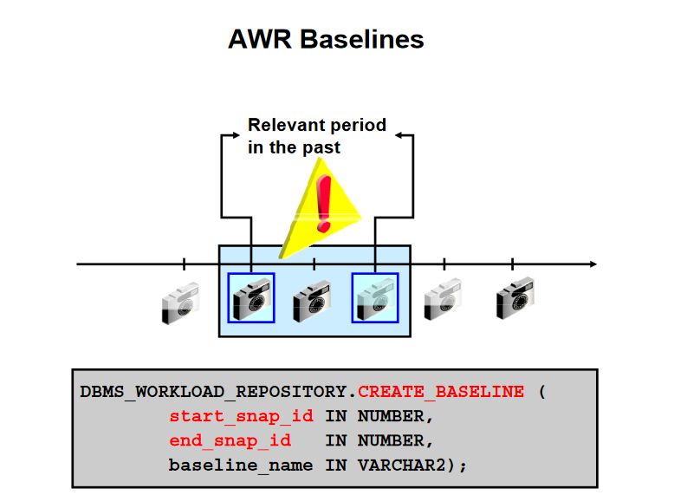

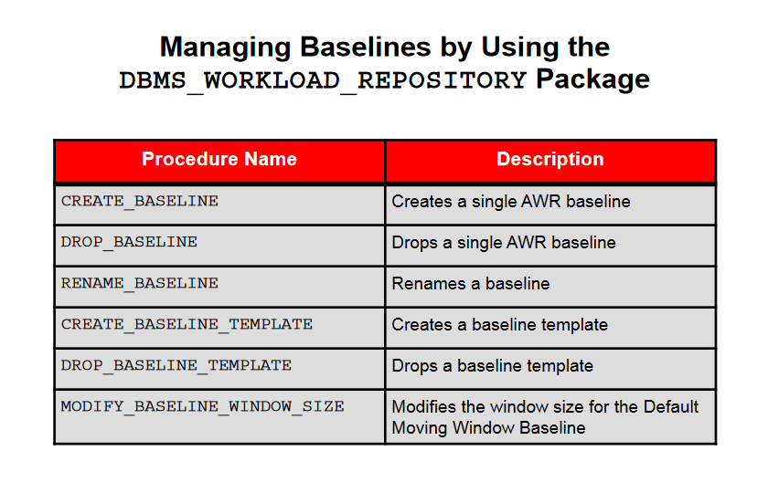

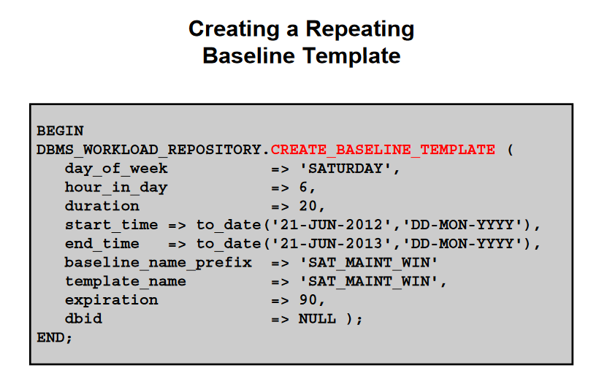

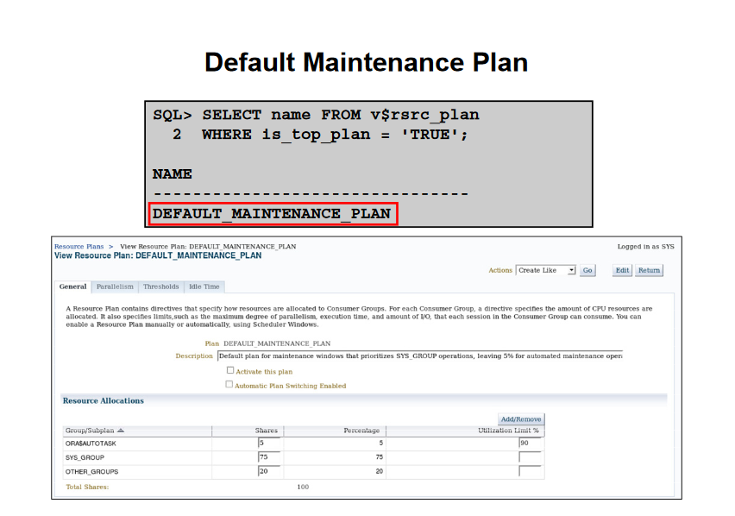

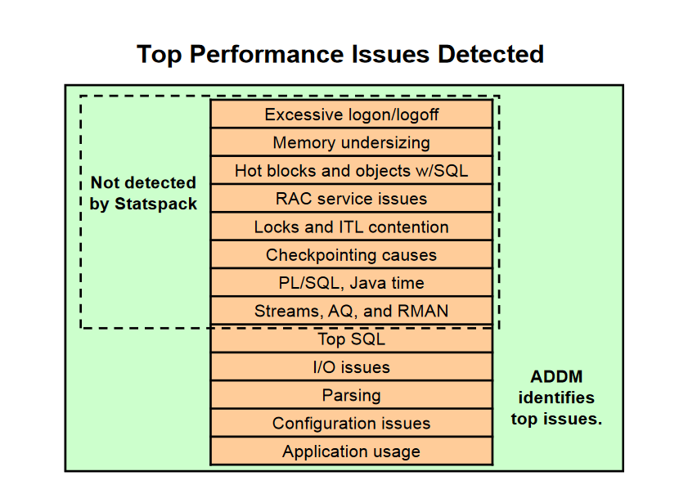

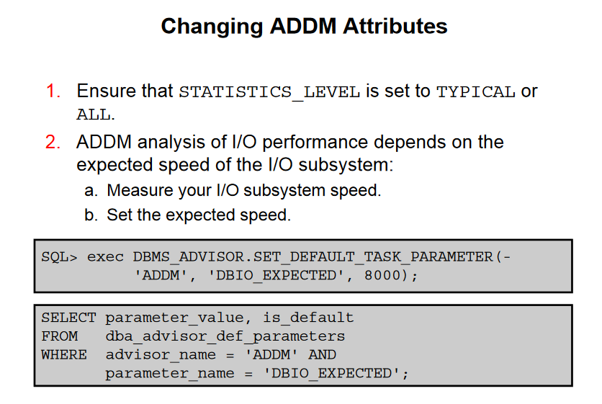

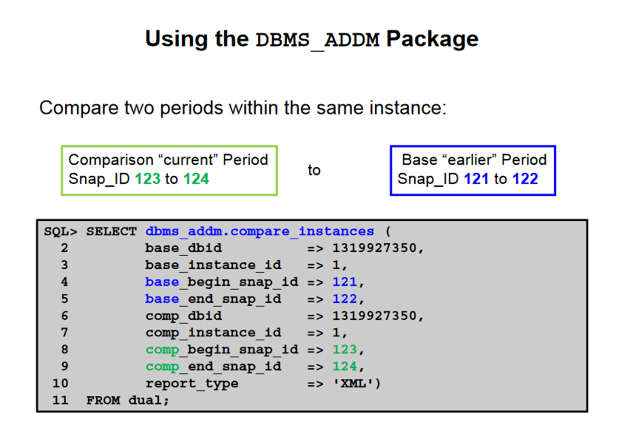

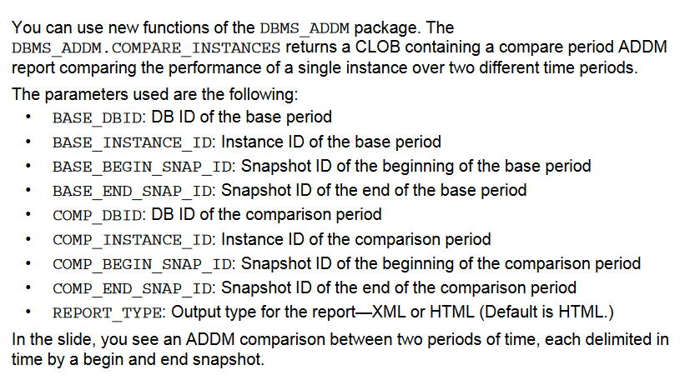

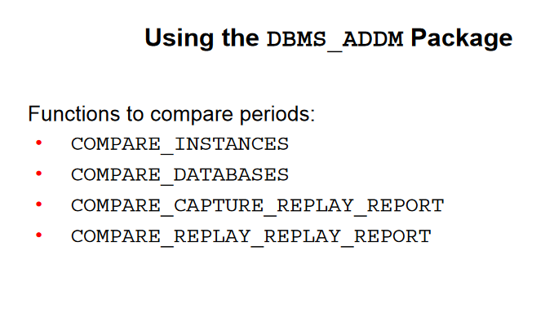

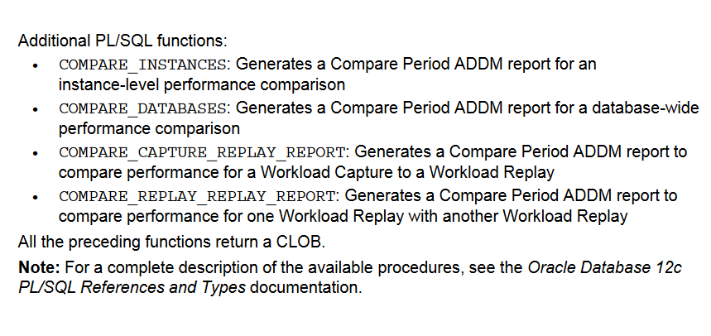

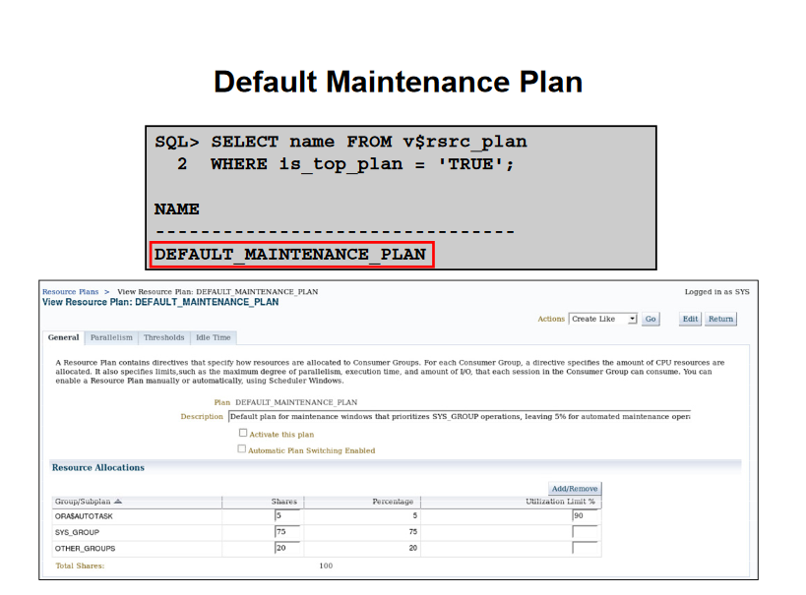

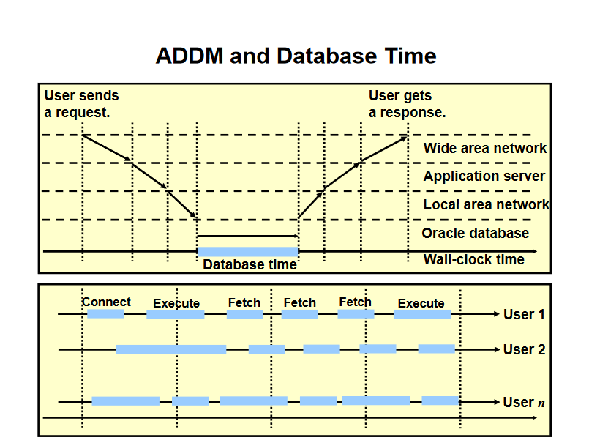

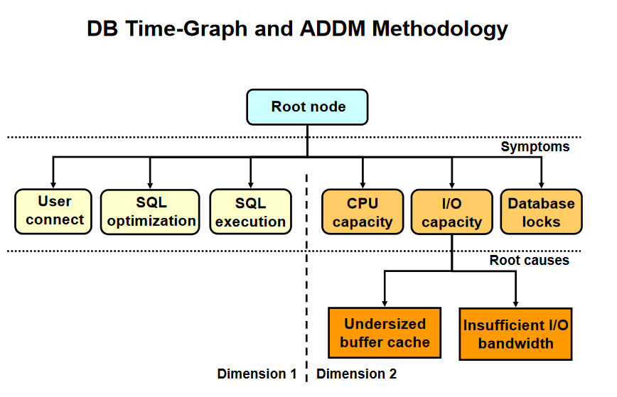

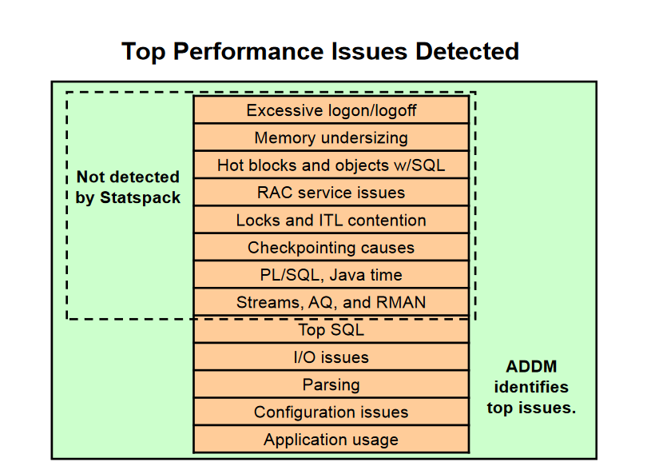

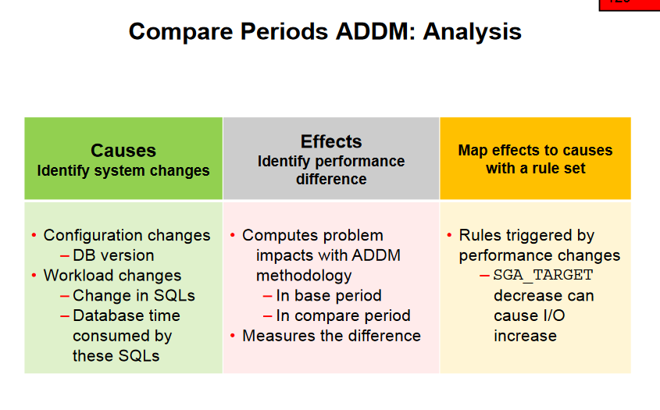

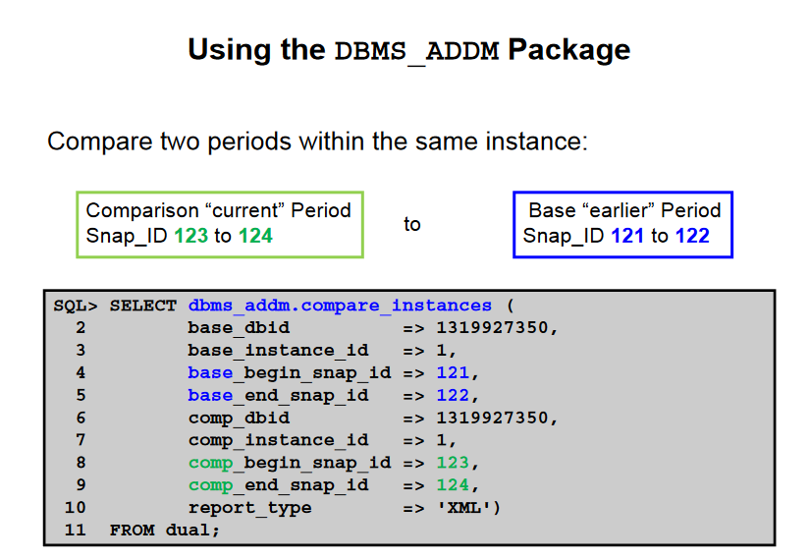

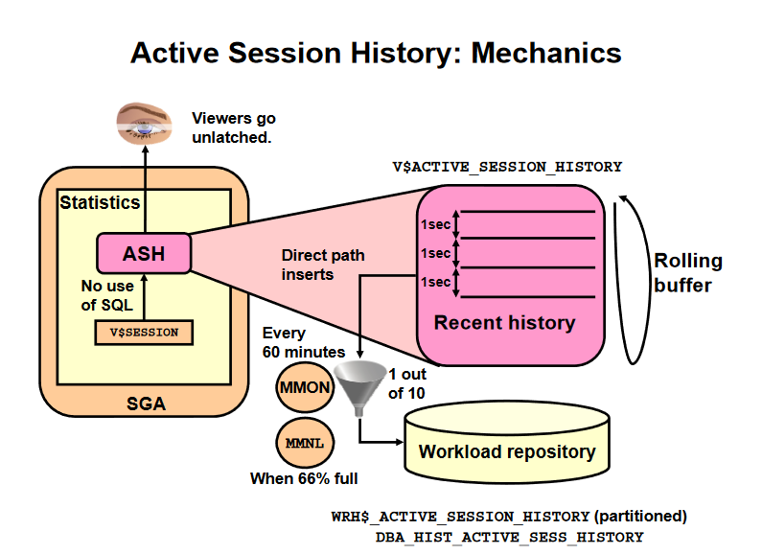

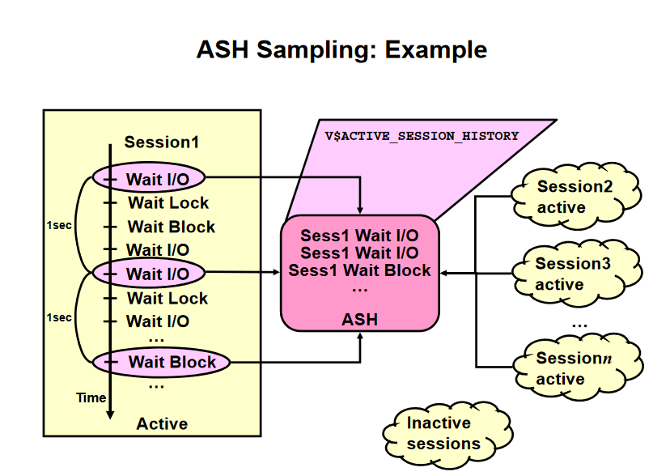

SELECT sql_id, count(*),

round(count(*)/sum(count(*)) over (), 2) pctload

FROM v$active_session_history

WHERE sample_time > sysdate -1/24/60 and

session_type <> 'BACKGROUND'

GROUP BY sql_id

ORDER BY count(*) desc;

Executing the ASH Report Script

SQL> define dbid = '';

SQL> define inst_num = '';

SQL> define report_type = 'html';

SQL> define begin time='09:00';

SQL>definebegin_time09:00 ;

SQL> define duration = 480;

SQL> define report_name = '/tmp/sql_ashrpt.txt';

SQL> define slot_width = '';

SQL> define target_session_id = '';

SQL> define target_sql_id = 'abcdefghij123';

SQL> define target_wait_class = '';

SQL> define target_service_hash = '';

SQL> define target_module_name = '';

SQL> define target_action_name = '';

SQL> define target_client_id = '';

SQL> @?/rdbms/admin/ashrpti

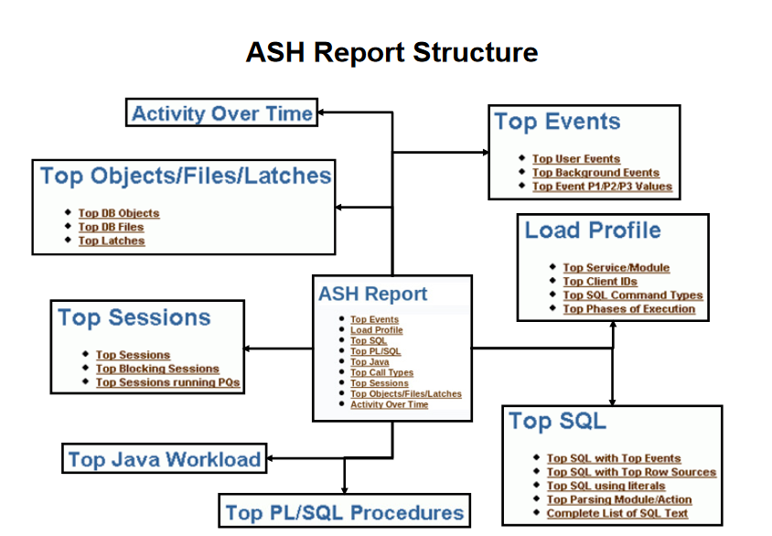

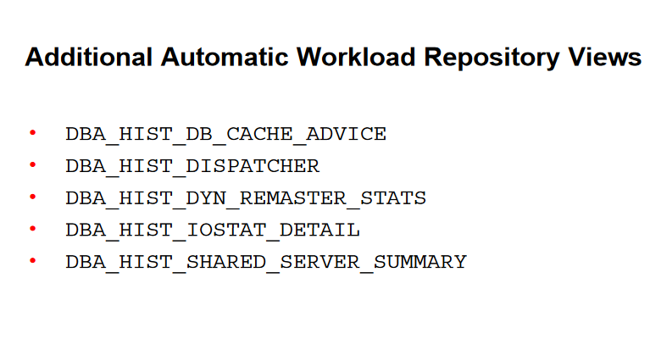

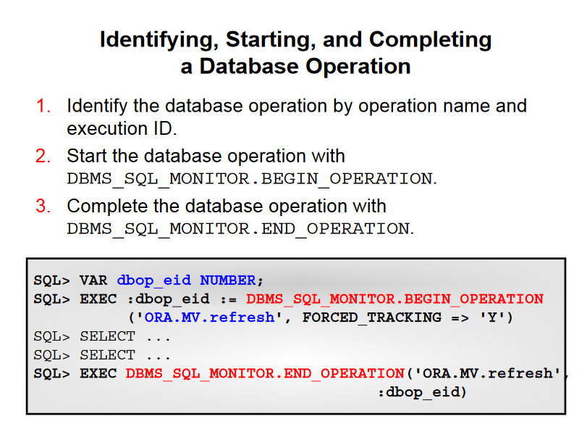

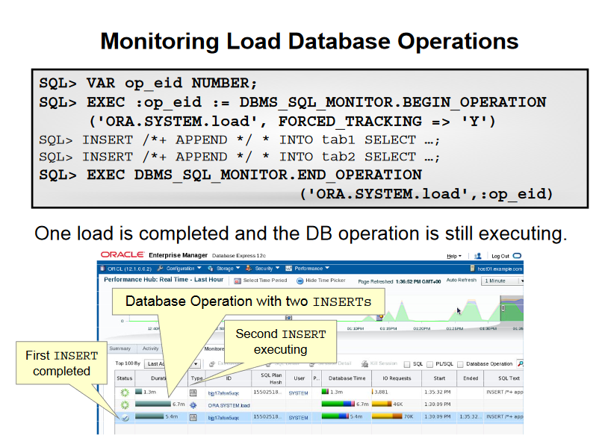

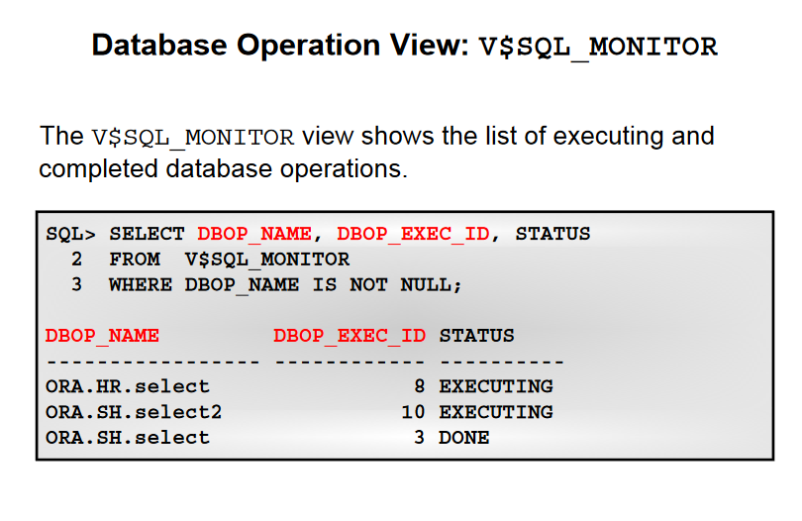

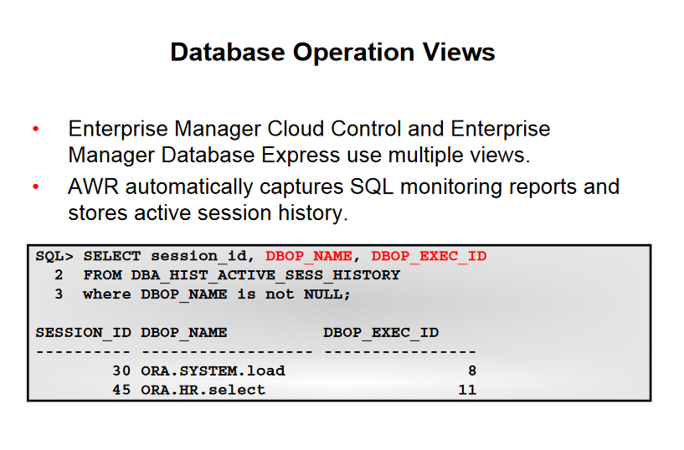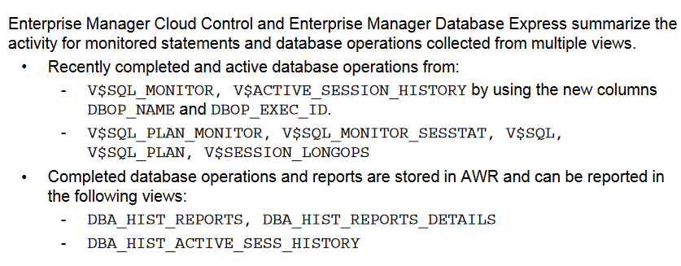

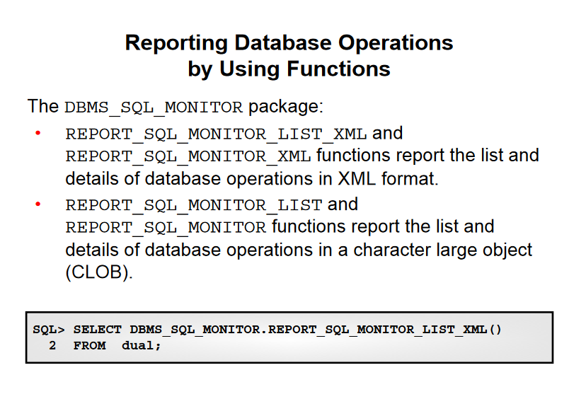

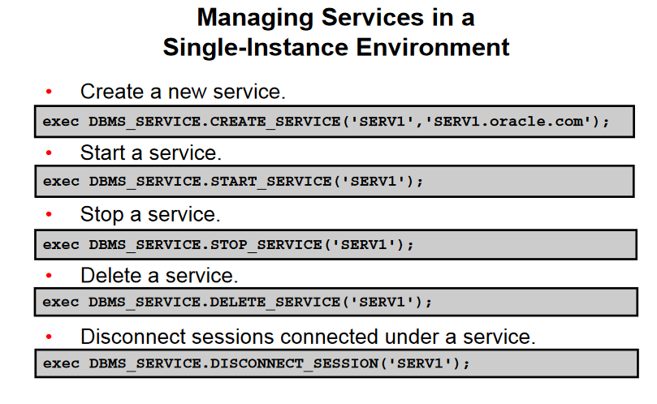

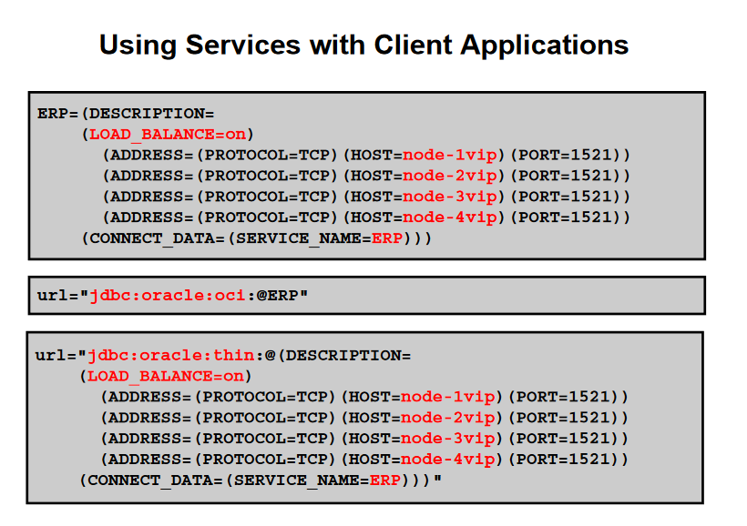

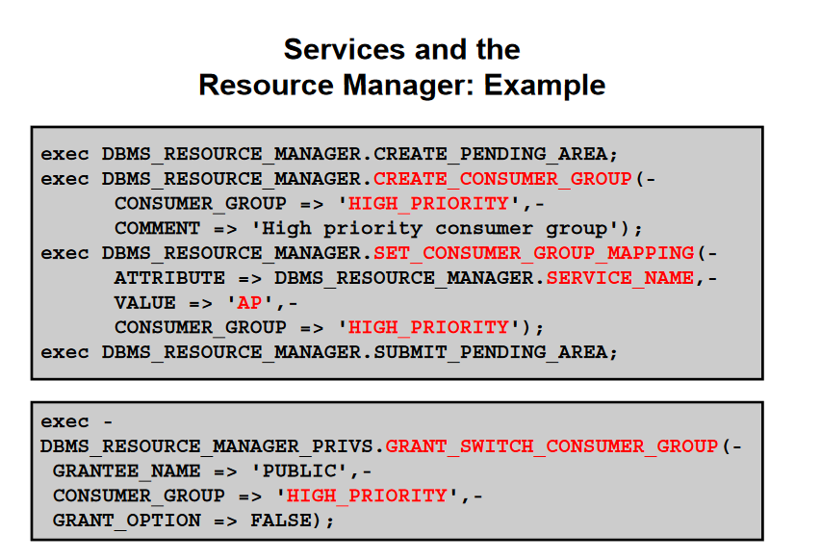

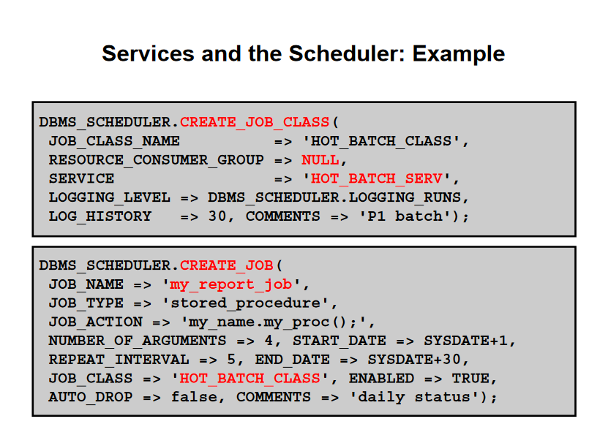

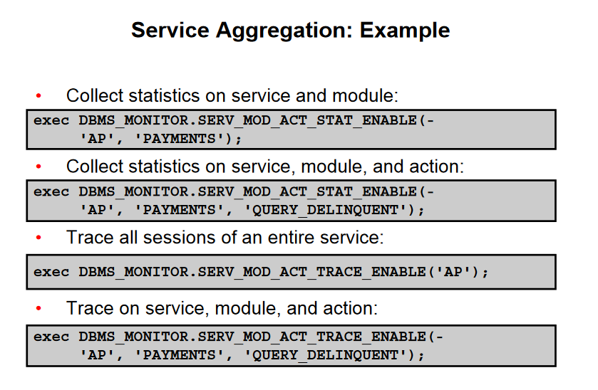

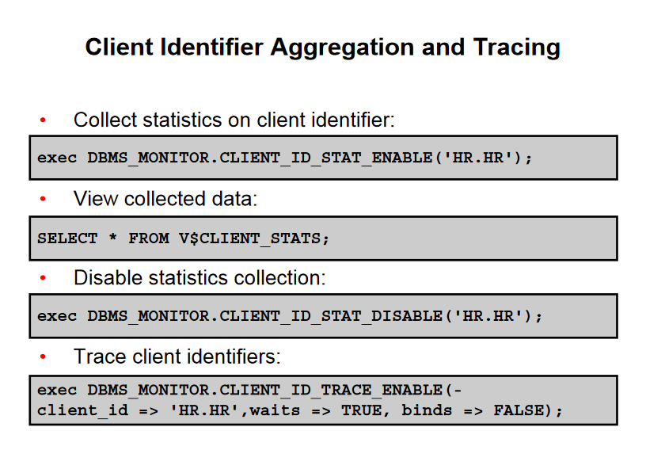

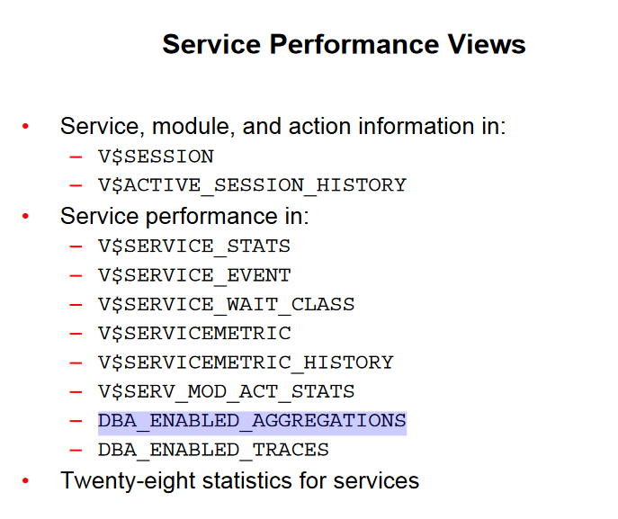

SELECT service_name, stat_name, value

FROM V$SERVICE_STATS

WHERE service_name = 'SERV1';

SQL> SELECT service_name, elapsedpercall, cpupercall,

dbtimepercall, dbtimepersec

FROM V$SERVICEMETRIC

WHERE service_name = 'SERV1‘;

If the bind variable does not match the type of the column, an implicit conversion will take libl ihiiihif idUhplace possibly preventing the optimizer in choosing fast access indexes. Use the DBA_HIST_SQLBINDview to find the actual types used.

